Soil Amendment Activity Instructions
Objective:
This activity has two goals. The first goal is to ensure PSA Grower Training attendees can determine if a soil amendment is a Biological Soil Amendments of Animal Origin (BSAAO) or not. The second goal is to ensure attendees can determine if a BSAAO is treated or untreated. Understanding these concepts is critical to moving on to discussions of reducing risks during application.
Prior to teaching Module 3:
- Print the Soil Amendment Activity slides and laminate the pages.
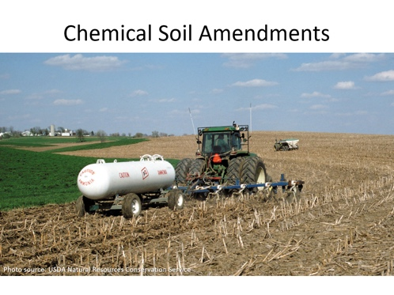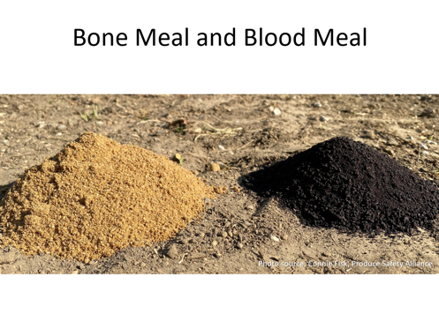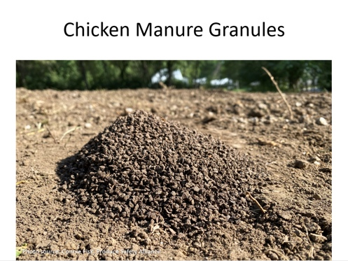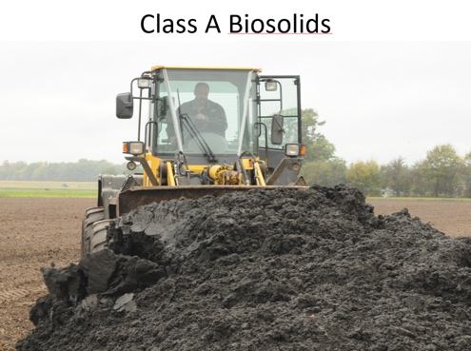
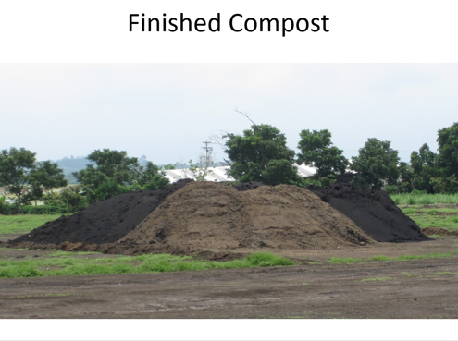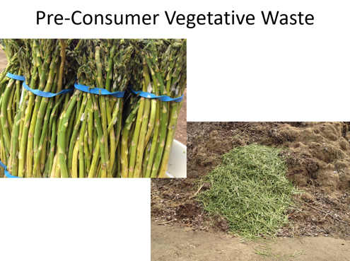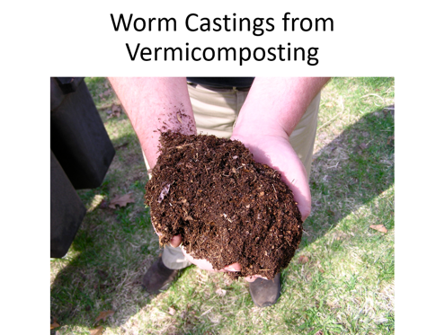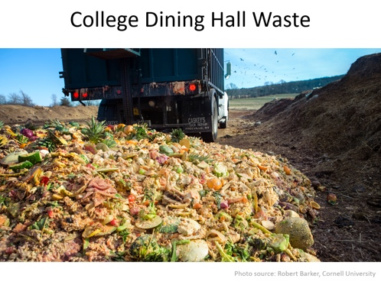
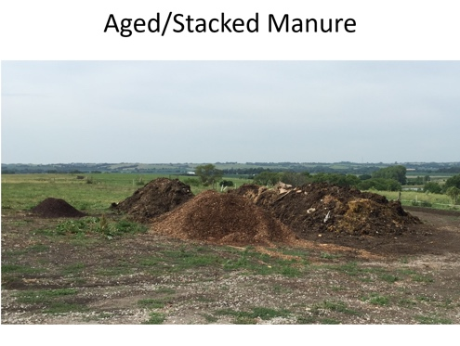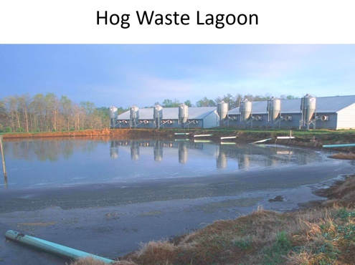
After teaching Module 3, slide 15 Treated Soil Amendments (or optional slide 16, Composting Options, if using):
- Hold the cards up one by one and ask the audience if each soil amendment is a BSAAO or not. If it is not a BSAAO, set it down. If it is a BSAAO, ask them if it is treated or untreated. You will have three stacks at the end of the activity: non-BSAAO, treated BSAAO, and untreated BSAAO.
- For each category of sorted cards, ask the audience if they think application of the soil amendment to a produce crop represents a high or low microbial risk. This is a good transition to the next part of the module, implementing practices to reduce risk.

Credit: This activity was adapted from an activity originated by Trevor Suslow, UC Davis
Background information on soil amendment photos:
Aged/Stacked Manure – Untreated BSAAO
Photo source: Connie Fisk, Produce Safety Alliance, Cornell University

Bone Meal and Blood Meal – Treated BSAAO
Photo source: Connie Fisk, Produce Safety Alliance, Cornell University

Chemical Soil Amendments – Not a BSAAO
Notes from Module 3, slide 7:
- Chemical and synthetic fertilizers usually do not present microbial risks because they either 1) do not support the growth of human pathogens or 2) are processed in such a way that eliminates pathogens.
- However, chemical amendments should not be considered 100% safe. Though rare, chemical amendments have been linked to outbreaks in the past.

Photo source: USDA Natural Resources Conservation Service

Chicken Manure Granules – Treated BSAAO
Photo source: Connie Fisk, Produce Safety Alliance, Cornell University

Class A Biosolids – Not a BSAAO
- Biological soil amendment of animal origin means a biological soil amendment which consists, in whole or in part, of materials of animal origin, such as manure or non-fecal animal byproducts including animal mortalities, or table waste, alone or in combination. The term ‘‘biological soil amendment of animal origin’’ does not include any form of human waste.
- “Biosolids” refers to treated sewage sludge that meets the EPA pollutant and pathogen requirements for land application and surface disposal.
(Source: https://www3.epa.gov/region9/water/npdes/sludge.html)
- Class A Biosolids is a designation for dewatered and heated sewage sludge that meets U.S. EPA guidelines for land application with no restrictions. Thus, class A biosolids can be legally used as fertilizer on farms, vegetable gardens, and can be sold to home gardeners as compost or fertilizer. (Source: https://www.sourcewatch.org/index.php/Class_A_Biosolids)
- One well-known example is Milorganite, manufactured by the Milwaukee Metropolitan Sewerage District. The District captures wastewater from the metropolitan Milwaukee area, including local industries such as MillerCoors. Using large-scale processes, microbes digest organic matter found in the water. The product is then heat-dried at 900-1,200°F (482-649°C), which kills pathogens, and then pelletized. The treated wastewater is discharged to Lake Michigan. (Sources: https://www.milorganite.com/using-milorganite/what-is-milorganite, Wikipedia)

Note from Module 3, slide 4:
- The term ‘biological soil amendment of animal origin’ does not include any form of human waste (§ 112.3(c)).

Notes from Module 3, slide 8:
- 40 CFR part 503, subpart D, limits application for land growing covered produce to Class A biosolids.
- Biosolids may also contain high levels of heavy metals or other contaminants such as pharmaceuticals.
- Management of biosolids is not discussed in detail in this module because its use is infrequent in fruit and vegetable production.

Photo source: SuSanA Secretariat on flickr, CC BY 2.0, available at https://www.flickr.com/photos/gtzecosan/6305610332

College Dining Hall Waste – Untreated BSAAO
Notes from Module 3, slide 9:
- Table wastes (leftovers) or wastes that could be contaminated by domesticated animals (e.g., cats or dogs) feces are considered untreated biological soil amendments of animal origin.
- Table wastes can also be contaminated with saliva or by contact with hands.

Photo source: Robert Barker, Cornell University. A truck dumps Cornell dining hall food waste at the university’s composting facility in March 2017.

Finished Compost – Treated BSAAO
- Even though these piles are finished compost, leaving them exposed to the environment means they can be contaminated by wildlife. If this happens, they are no longer treated.

Photo source: Connie Fisk, Produce Safety Alliance, Cornell University

Hog Waste Lagoon – Untreated BSAAO
Photo source: USDA Natural Resources Conservation Service

Pre-Consumer Vegetative Waste – Not a BSAAO
Note from Module 3, slide 9:
- In § 112.3(c), pre-consumer vegetative waste means solid waste that is purely vegetative in origin, not considered yard trash, and derived from commercial, institutional, or agricultural operations without coming in contact with animal products, byproducts or manure or with an end user (consumer). Pre-consumer vegetative waste includes material generated by farms, packinghouses, canning operations, wholesale distribution centers and grocery stores; products that have been removed from their packaging (such as out-of-date juice, vegetables, condiments, and bread); and associated packaging that is vegetative in origin (such as paper or corn-starch based products). Pre-consumer vegetative waste does not include table waste, packaging that has come in contact with materials (such as meat) that are not vegetative in origin, or any waste generated by restaurants.

Photo source: Connie Fisk, Produce Safety Alliance, Cornell University. Rotting asparagus. Rubber bands were removed and it was added to the yard waste pile at the landfill.

Worm Castings from Vermicomposting – Untreated BSAAO
- Composting with worms (also called vermicomposting) is usually done with the common red wiggler worm (Eisenia fetida). This worm’s specialized digestive system converts food waste and other organic materials to a nutrient-rich compost called vermicast or worm castings. It thrives in an aerobic (with air) environment. It is able to process large amounts of food waste and rapidly reproduce in a confined space.
- Vermicomposting is considered a “cold” composting process. There is no noticeable heat generated by bacteria during the decomposition process. (Source: https://ir.library.oregonstate.edu/downloads/vq27zn937)
- Comment 277 in the preamble provides validation info on vermicompost. It says, “Therefore, stabilized compost produced by static composting processes, end products of vermicomposting processes, or stabilized compost produced through time/temperature combinations other than those described in § 112.54(c)(1) and (2) may be considered ‘‘treated’’ provided that they meet the requirements of § 112.54, including satisfying one of the microbial standards in § 112.55.”
- As it currently stands, based on FDA feedback, vermicast does not meet the microbial standards of the FSMA Produce Safety Rule unless it goes through another treatment step either before or after the vermicomposting. So for the purpose of this activity, it is an untreated BSAAO. There are continuing discussions and research around this topic, so be aware this understanding is subject to change.

Photo source: blog post by Rhonda Sherman, NCSU available at https://www.carolinafarmstewards.org/producing-vermicompost/

