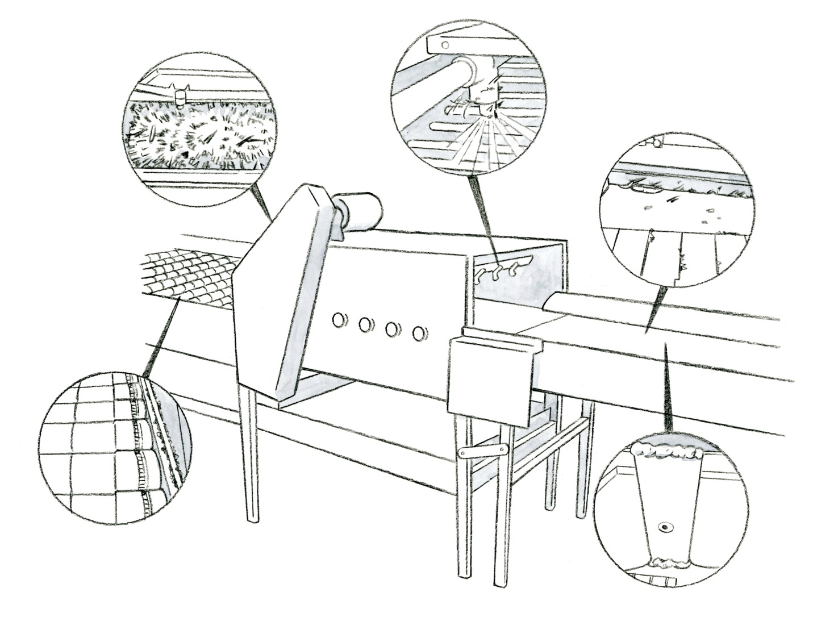
Sanitation Challenges - Hard to Clean Equipment
Illustration Guide and Teaching Notes
5
1
2
3
4
Key Teaching Points
The sanitation of postharvest washing and packinghouse equipment is critical to minimizing cross-contamination of fresh produce. Not all equipment that produce contacts, directly or indirectly, has been built with principles of sanitary design in mind. Ideally, materials used in the construction of equipment should be non-porous and easy to clean. According to FSMA Produce Safety Rule (PSR)
§ 112.123 equipment must be adequate in design and construction to enable them to be adequately cleaned and maintained. The illustration shows a piece of small-scale produce washing equipment. Five call-outs show areas that are challenging to clean and where potential harborage sites may exist for microbial pathogens. Each area is described below. The numbers below align with key teaching points in the above illustration.
  - Rollers. Diverse materials are used to construct rollers. Occasionally foam-based rollers and bumpers are used to prevent produce from getting damaged during movement along the line. If the foam is not closed cell, it could absorb water, providing moisture to support bacterial survival and serve as a source of contamination.
  - Brushes. Often used to remove debris and soil from produce, brushes have the potential to trap debris that could harbor microbial pathogens and are notoriously difficult to clean. In many cases, brushes are not easily removed from the equipment for cleaning and sanitation but effort needs to be expended to ensure brushes are properly cleaned to reduce food safety risks.
  - Spray nozzles. Water from spray nozzles will directly contact the produce so it is important that they be cleaned and well maintained. It is not uncommon for dirt and debris to build up on nozzles, so equipment cleaning Standard Operating Procedures (SOPs) should include cleaning the spray nozzles.
  - Equipment walls and conveyors. Produce will directly contact the side walls and conveyor belts of equipment, therefore sanitation of these surfaces is a high priority. Pay particular attention to areas where a conveyor may have bends or corners where debris could build up. Some conveyors are solid belts, while others are made of metal linked together. Depending on the type of conveyor belt, sanitation practices may be different which is why it is important to develop an SOP and train all workers on cleaning practices and expectations.
  - Equipment joints and welds. Joints and improper welds are a great place for microbial pathogens, both human and plant, to hide. Welds should be smoothly bonded and joints rounded wherever possible. Sanitation programs should focus on ensuring debris build-up is removed from these areas.
Relevant FSMA PSR Provisions
- § 112.123
Suggested for Use in PSA Grower Training Version 1.2
- Module 6: Postharvest Handling and Sanitation after Slide 24

