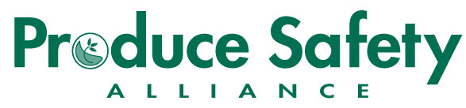

Insert Your Organization’s Logo Here

**Remote PSA Grower Training Course Agenda**

<Online Platform>

<Month – Date – Year>

<Time>

<Sponsors/Hosts>

*All times based on <Time Zone>*

**DAY 1 (DATE)**

7:30 AM *Log in to <Online platform>, Sign In, Audio Checks*

8:00 AM Welcome, Introductions, and Course Expectations

8:30 AM Module 1: Introduction to Produce Safety

9:30 AM Module 2: Worker Health, Hygiene, and Training

10:30 AM *Break*

10:45 AM Module 3: Soil Amendments

11:30 AM Module 4: Wildlife, Domesticated Animals, and Land Use

12:15 PM *Day 1 Summary and Final Questions*

12:30 PM *Adjourn, Log Out*

**DAY 2 (DATE)**

7:50 AM *Log in to <Online platform>, Sign In, Audio Checks*

8:00 AM Welcome back. Day 1 Recap

8:30 AM Module 5: Agricultural Water – Part I: Production Water

9:30 AM Module 5: Agricultural Water – Part 2: Postharvest Water

10:15 AM *Break*

10:30 AM Module 6: Postharvest Handling and Sanitation

11:30 AM Module 7: How to Develop a Farm Food Safety Plan

12:15 PM *Final Questions, Closing Statements and Evaluations*

12:30 PM *Adjourn, Log Out*