Proper Use of Hand Sanitizer
Illustration Guide and Teaching Notes
2
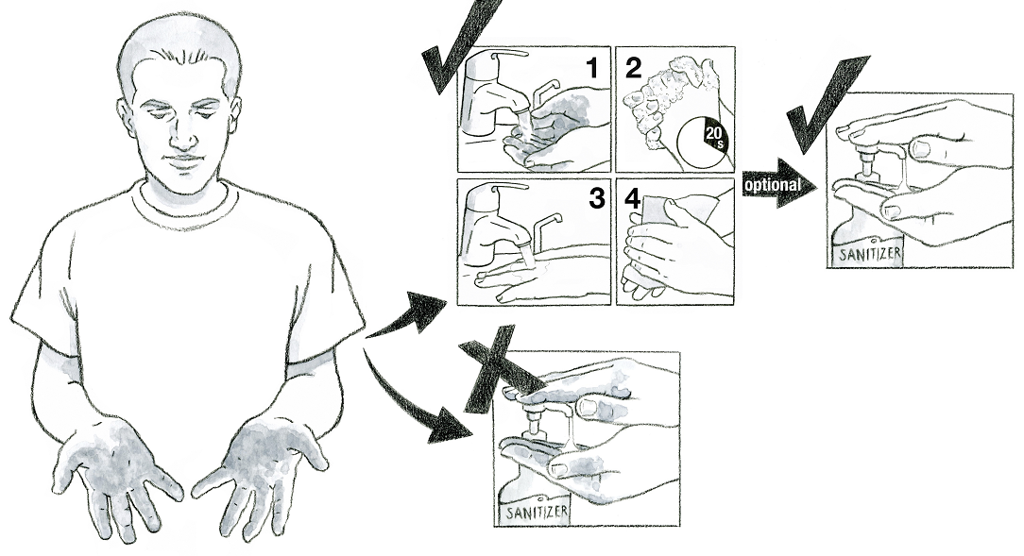
1
4
3

Key Teaching Points
This illustration highlights that handwashing must always come before the use of hand sanitizers. The numbers below align with key teaching points in the above illustration.
- The FSMA Produce Safety Rule (PSR) § 112.130(d) states that antiseptic hand rubs are not a substitute for handwashing with soap (or other effective surfactant) and water. This is the most important message within this illustration.
- This is a reminder of the steps involved in properly washing hands: 1) wet the hands with water, 2) apply soap and rub vigorously for at least 20 seconds making sure to get between the fingers and the front and back of the hands, 3) rinse with clean water and 4) dry with a single-use paper towel or other sanitary method.
- After the handwashing process is complete, a hand sanitizer can be used as an optional fifth step. Handwashing removes dirt from the hands, allowing the sanitizer to work properly.
- Sanitizers alone do not effectively remove dirt from hand surfaces and cannot work effectively if hands have dirt on them. Handwashing must come first.

Additional Discussion Topics Related to Handwashing
- The water used for handwashing activities must have no detectable generic
E. coli. Untreated surface water must not be used for handwashing (FSMA PSR § 112.44(a)).
- The faucet should be turned off using the single-use towel after drying the hands. This will avoid contaminating the fleshly clean hands.
- Hands must be washed after using the toilet, before starting or returning to work, before putting on gloves, after touching animals or animal waste, or any other time hands may become contaminated (FSMA PSR § 112.32(b)(3)).
- Handwashing facilities must have soap (or other effective surfactant), clean water, a sanitary way to dry hands, and appropriate containers for waste disposal (FSMA PSR § 112.130).

Relevant FSMA PSR Provisions
- § 112.32(b)(3)
- § 112.44(a)
- § 112.130
- § 112.130(d)

Suggested for Use in PSA Grower Training Version 1.2
- Module 2: Worker Health, Hygiene, and Training after Slides 5, 17, or 23

Supporting Resources
- Washington State Department of Agriculture—FSMA PSR Handwashing Poster
- Produce Safety Alliance—Everyone should wash their hands for at least 20 seconds (English)
- Produce Safety Alliance—Everyone should wash their hands for at least 20 seconds (Spanish)

