**Microorganisms Can Be Found on Produce Surfaces**

**Illustration Guide and Teaching Notes**

1

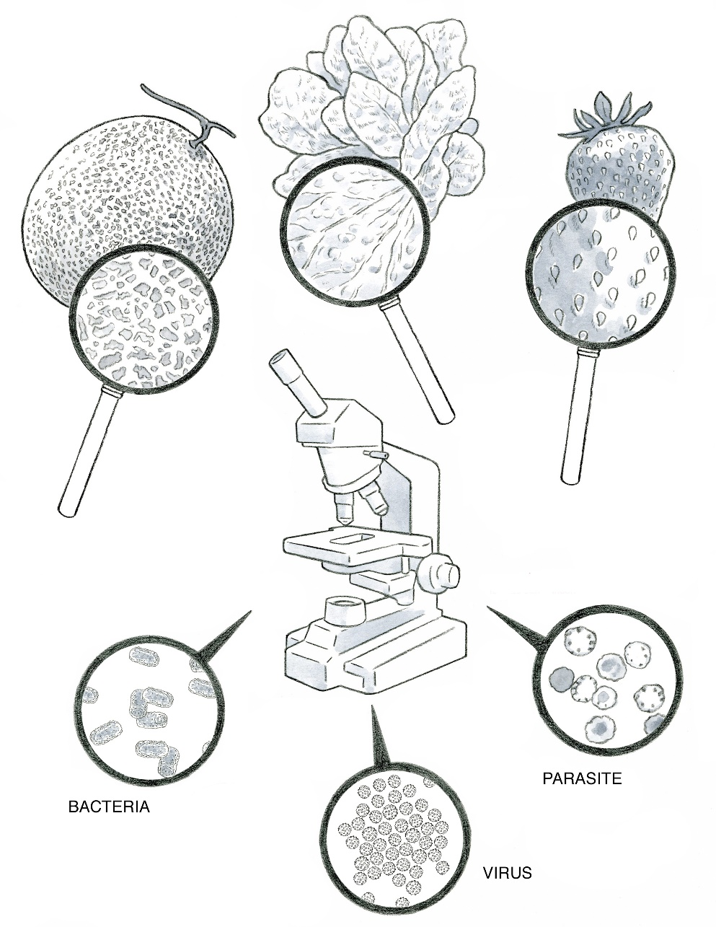

2

**Key Teaching Points**

This illustration is intended to highlight how produce surfaces can provide niches for microorganisms to exist, attach, and grow. It is extremely difficult to remove microbial contamination on produce once it occurs; for this reason, growers should focus on preventing contamination through Good Agricultural Practices. The numbers below align with key teaching points in the above illustration.

* 1. The magnifying glasses illustrate a magnified view of the cantaloupe rind, lettuce leaves, and strawberry skin (left to right). These produce surfaces have different structures and areas where microorganisms, including pathogens, might have a higher chance of persistence, attachment, and growth. The magnified view of the cantaloupe shows a rough, netted surface that provides many areas where microorganisms can attach. During washing, these nooks can provide hydrophobic areas where microorganisms are protected from sanitizers that may be in wash water (Beuchat, 1997; Ukuki, 2002; Parnell, 2005; Park, 1999). In addition, when the stem is removed, the stem scar that remains is more susceptible to infiltration if the melons are submerged in wash water. The magnified area of the lettuce shows large folded areas that allow microorganisms to be concealed on the leaf. These leaves also have stomata (tiny openings in the leaf surface to allow for gas exchange) that can trap or provide microorganisms with access to attachment sites. The magnified view of the strawberry surface contains many achenes (seed-bearing structures) surrounded by receptacle tissue (red flesh). These areas as well as the calyx (cap) provide many crevices for microorganisms to adhere. Each of these examples illustrates why it is difficult to remove microbial pathogens from the produce surface. Additionally, these produce items are often consumed raw, so there is no cooking or “kill step” to destroy microbial pathogens.
  2. The microscope indicates that a higher level of magnification is needed to visualize the microscopic pathogens in the lower half of this illustration. Microorganisms, such as bacteria, viruses, and parasites, are smaller than produce surfaces and difficult to detect visually without magnification. Three pathogen types are illustrated (left to right): bacteria (*Salmonella enterica*), viruses (Hepatitis A), and parasites (*Cyclospora cayetanensis).* Each of the pathogens listed here have caused produce-associated outbreaks.

**Suggested for Use in PSA Grower Training Version 1.2**

* Module 1: Introduction to Produce Safety after Slide 10 or 17

**Supporting Resources**

* FDA—[Bad Bug Book](https://www.fda.gov/food/foodborne-pathogens/bad-bug-book-second-edition).
* FDA—[Potential for Infiltration, Survival, and Growth of Human Pathogens within Fruits and Vegetables](https://www.fda.gov/food/hazard-analysis-critical-control-point-haccp/potential-infiltration-survival-and-growth-human-pathogens-within-fruits-and-vegetables).
* USDA Food Safety Inspection Service—[Illnesses and Pathogens](https://www.fsis.usda.gov/food-safety/foodborne-illness-and-disease/illnesses-and-pathogens).
* Emerging Infectious Diseases—[Produce Handling and Processing Practices](https://www.ncbi.nlm.nih.gov/pmc/articles/PMC2640071/pdf/9366597.pdf).
* Dairy, Food and Environmental Sanitation—[Evaluation of Sanitizers for Killing *Escherichia coli* O157:H7, *Salmonella*, and Naturally Occurring Microorganisms on Cantaloups, Honeydew Melons, and Asparagus](https://www.foodprotection.org/upl/downloads/journal-archive/dairy-food-and-environmental-sanitation-1999-volume-19-issue-12.pdf).
* International Journal of Food Microbiology—[Reducing *Salmonella* on cantaloupes and honeydew melons using wash practices applicable to postharvest handling, foodservice, and consumer preparation](https://www.sciencedirect.com/science/article/abs/pii/S0168160504004015?via%3Dihub).
* Journal of Food Protection—[Relationship of Cell Surface Charge and Hydrophobicity to Strength of Attachment of Bacteria to Cantaloup Rind](https://www.sciencedirect.com/science/article/pii/S0362028X22049535?via%3Dihub).