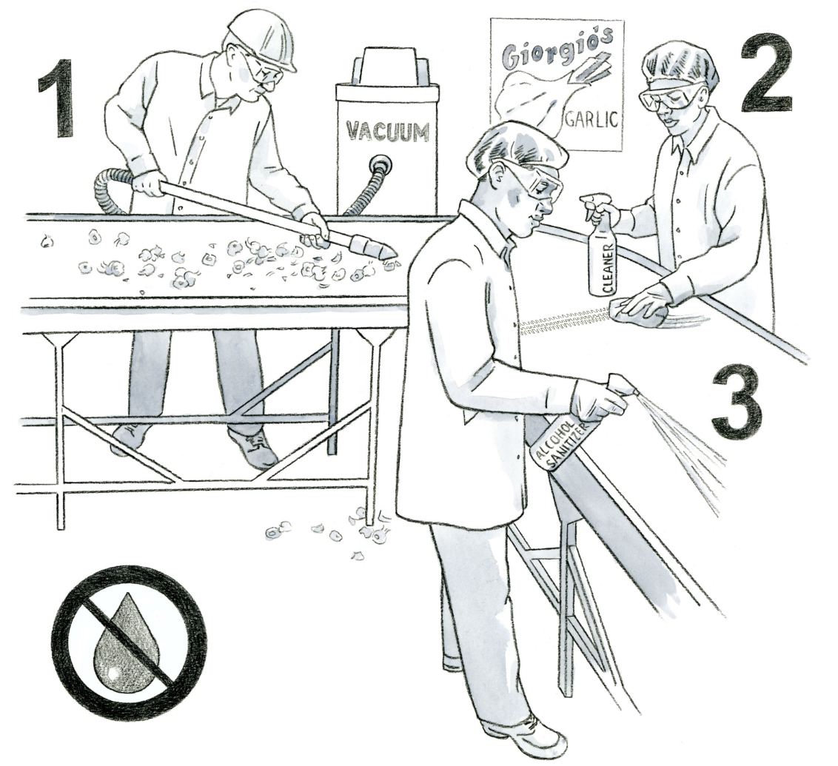
Packinghouse Sanitation - Dry Cleaning
Illustration Guide and Teaching Notes

Key Teaching Points
In this illustration, workers in a garlic factory demonstrate the three steps to cleaning and sanitizing a packing line using dry cleaning techniques. Dry cleaning is often performed in operations that handle foods that are already dry and have low water activity. It can also be used in facilities that have difficulty properly managing water. Food contact surfaces (zone 1 surfaces) must be inspected, maintained, cleaned, and, when necessary and appropriate, sanitized. Review the requirements in
the FSMA Produce Safety Rule (PSR) §§ 112.123(d)(1) and (d)(2). Please note, this illustration includes all these steps happening simultaneously but in normal circumstances, they would be separated by time. The numbers below align with key teaching points in the above illustration.
- Pre-cleaning is the first step of the dry-cleaning process. The purpose is to remove any obvious dirt and debris from the food contact surface. In the illustration, the worker is using a vacuum to remove the garlic wrappers and debris. Brushes, scrapers, and air blowers can also be used.
- The second step of dry-cleaning is cleaning, as shown by the worker wiping down the conveyor belt. This can be done by scrubbing the surface to remove all soil from the surfaces. A food-grade alcohol-based detergent, dry or low-moisture steam, or pelletized CO₂ can be used instead of water-based detergents for this step.
- Lastly, the third step is sanitizing with a sanitizer approved for food contact surfaces. One option, shown in this illustration, would be spraying the surface with a high-percentage isopropyl alcohol and letting the surface dry.
Relevant FSMA PSR Provisions
- § 112.123 (d)(1)
- § 112.123 (d)(2)

Suggested for Use in PSA Grower Training Version 1.2
- Module 6: Postharvest Handling and Sanitation after Slide 21

Supporting Resources
- Cornell University Institute for Food Safety—Cleaning – Wet and Dry Cleaning (Part 2).

