Managing Post-Harvest Water and Change Schedules
Illustration and Teaching Notes
5
1
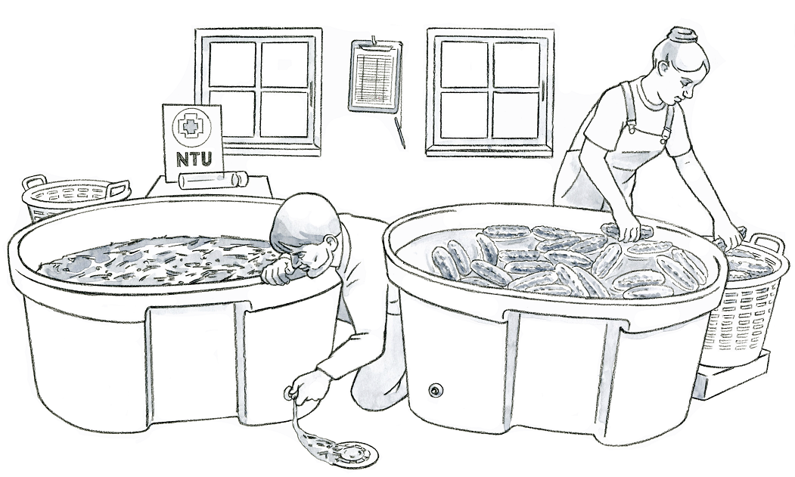
3
4
2
Key Teaching Points
In this illustration, cucumbers are being washed in large tubs in an indoor packing area. The numbers below align with key teaching points in the above illustration.
- Washing produce is not required in the FSMA Produce Safety Rule (PSR), however if produce is washed, there are required practices to minimize risks.
- Water used for harvest and postharvest activities must be visually monitored for the build-up of organic material according to FSMA PSR § 112.48(b). Here, a tool for monitoring turbidity (water cloudiness) is displayed behind the tub. Turbidity measurements are not required; however, they can be used as an indicator for when the water should be changed. The organic matter suspended in turbid water can make some sanitizer treatments less effective.
- The FSMA PSR § 112.48(a) requires that postharvest water must be managed by establishing water-change schedules for batch, or recirculated, systems. The worker on the left is draining the dirty water so that the tub may be refilled with clean water. The frequency of how often this change may occur will depend on several factors, including the type of sanitizer used, turbidity measurements, and organic load.
- Grey water from washing and cooling produce must be properly disposed of so that it does not contaminate food contact surfaces and other areas used for covered activities according to FSMA PSR §§ 112.132 and 112.133. The water from the tub is being discharged into a drain in the packing area to minimize risks of contamination from the grey water.
- A postharvest water monitoring record and pen are hanging on the wall for ease of recordkeeping. FSMA PSR §112.43(b) requires the results of water treatment monitoring to be documented.

Relevant FSMA PSR Provisions
- § 112.43(b)
- § 112.48(a)
- § 112.48(b)
- § 112.132
- § 112.133
Suggested for Use in PSA Grower Training Version 1.2
- Module 5.2 Agricultural Water Part 2: Postharvest Water after Slide 62

Supporting Resources
- Michigan State University Extension—Handling Turbidity in Postharvest Wash Water.
- Produce Safety Alliance—Records Required by the FSMA PSR.
- National Good Agricultural Practices Program—Postharvest Water Decision Tree.

