**In-field Pooling and Implications for Harvest**

**Illustration Guide and Teaching Notes**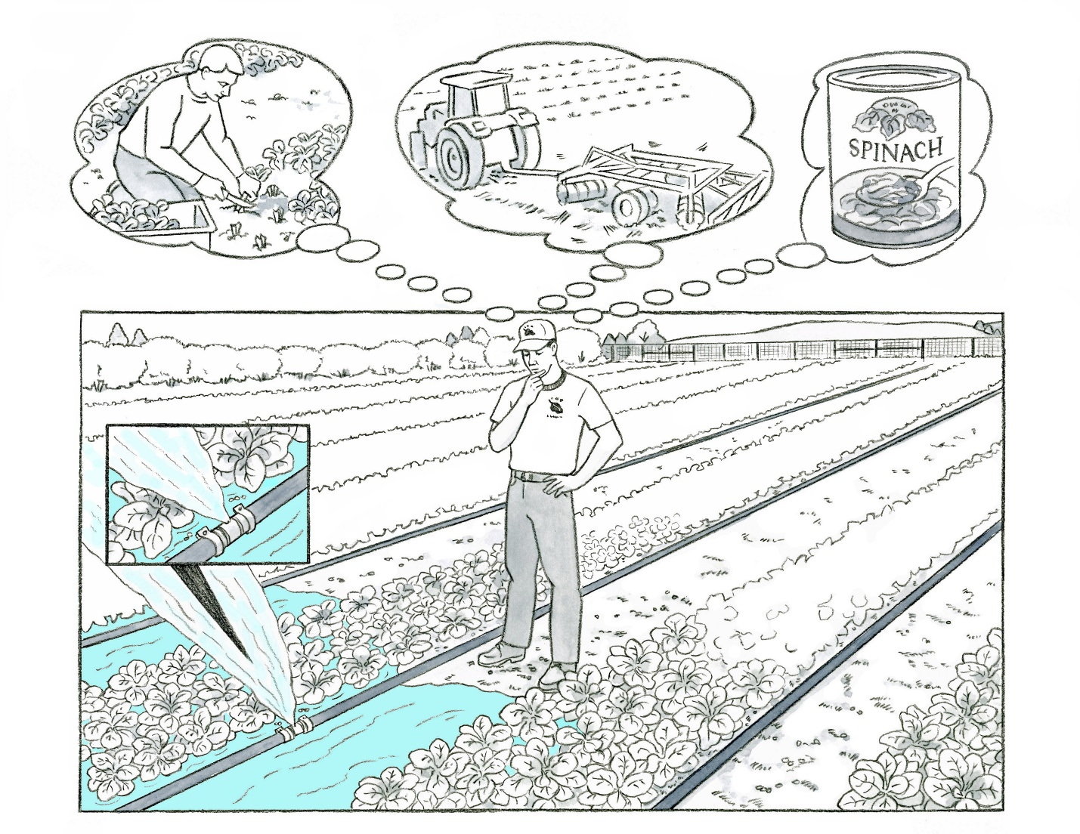

2

1

**Key Teaching Points**

This illustration is intended to define in-field pooling, highlight how pooling differs from flooding, and the implications pooling has on harvest. In-field pooling can occur during heavy rain events or when in-field irrigation equipment fails or is mismanaged. In this illustration, a break in the water distribution pipe allowed irrigation water to spray onto the harvestable portions of the spinach and pool in the surrounding rows. In-field pooling is different from unintentional flooding, since the water generally does not run off into other fields or contain other contaminating agents such as unknown chemical, physical, and biological hazards. There is an accompanying illustration entitled “Flooding and Implications for Harvest”, which provides more detail on flooding and produce adulteration. The numbers below align with key teaching points in the above illustration.

* 1. In this illustration, the pooled water originates from a broken irrigation line, not an overflowing stream, river, or lake, therefore the produce contacted by this water is not automatically considered adulterated. As indicated in the thought bubbles, the grower has several different things to consider before they decide how the crop can be used under this scenario. If the grower knows something about the quality of the water, is confident it is safe and of adequate sanitary quality, and the water is not likely to have resulted in crop contamination, the crop could be harvested and sold as fresh produce. If the grower is concerned with the quality of the water or is unsure, the field could be tilled under or the produce can be sold to a processor where a “kill-step” will be implemented. The grower will need to assess risks to make this determination.
  2. The FSMA Produce Safety Rule (PSR) requires growers to inspect the agricultural water systems that are under their control, including water sources, water distribution systems, facilities, and equipment. This should be completed at the beginning of a growing season or at least once annually. Regular inspections will reduce the potential of equipment failure throughout the growing season. Refer to FSMA PSR § 112.42 and comments 183 and 184 of the Preamble for further insights. In addition, as described in FSMA PSR § 112.42(d) and Preamble comment 190, the grower must implement measures to reduce the potential of the pooling waters to reach the harvestable portions of the crop, such as staking the crop or using an alternative irrigation method.

**Relevant FSMA PSR Provisions**

* § 112.42

**Relevant Federal Food, Drug, and Cosmetic Act (FD&C) Provisions**

* 21 U.S. Code, [FD&C Chapter 9, § 321(f)](https://www.law.cornell.edu/uscode/text/21/321) (establishes the definition of food)
* 21 U.S. Code, [FD&C Chapter 9, § 331](https://www.law.cornell.edu/uscode/text/21/331) (establishes prohibited acts, including the adulteration of any food in interstate commerce). Note: 21 USC § 331 is the same as Section 402 in the Code of Federal Regulations.
* 21 U.S. Code, [FD&C (Chapter 9), § 342](https://www.law.cornell.edu/uscode/text/21/342) (establishes the definition of adulteration)

**Suggested for Use in PSA Grower Training Version 1.2**

* Module 5-1 Agricultural Water Part 1: Production Water after Slide 19 or 38

**Supporting Resources**

* FDA [Guidance for Industry: Evaluating the Safety of Flood-affected Food Crops for Human Consumption](https://www.fda.gov/regulatory-information/search-fda-guidance-documents/guidance-industry-evaluating-safety-flood-affected-food-crops-human-consumption).
* FDA [Safety of Food and Animal Food Crops Affected by Hurricanes, Flooding, and Power Outages](https://www.fda.gov/food/food-safety-during-emergencies/safety-food-and-animal-food-crops-affected-hurricanes-flooding-and-power-outages).
* FDA [Resources for Human and Animal Food Producers Affected by Flooding](https://www.fda.gov/about-fda/office-human-and-animal-food-operations/resources-human-and-animal-food-producers-affected-flooding).
* FSMA PSR [Preamble Comments 183-184 and 190](https://www.govinfo.gov/content/pkg/FR-2015-11-27/pdf/2015-28159.pdf).