Harvest Equipment Sanitation
Illustration Guide and Teaching Notes

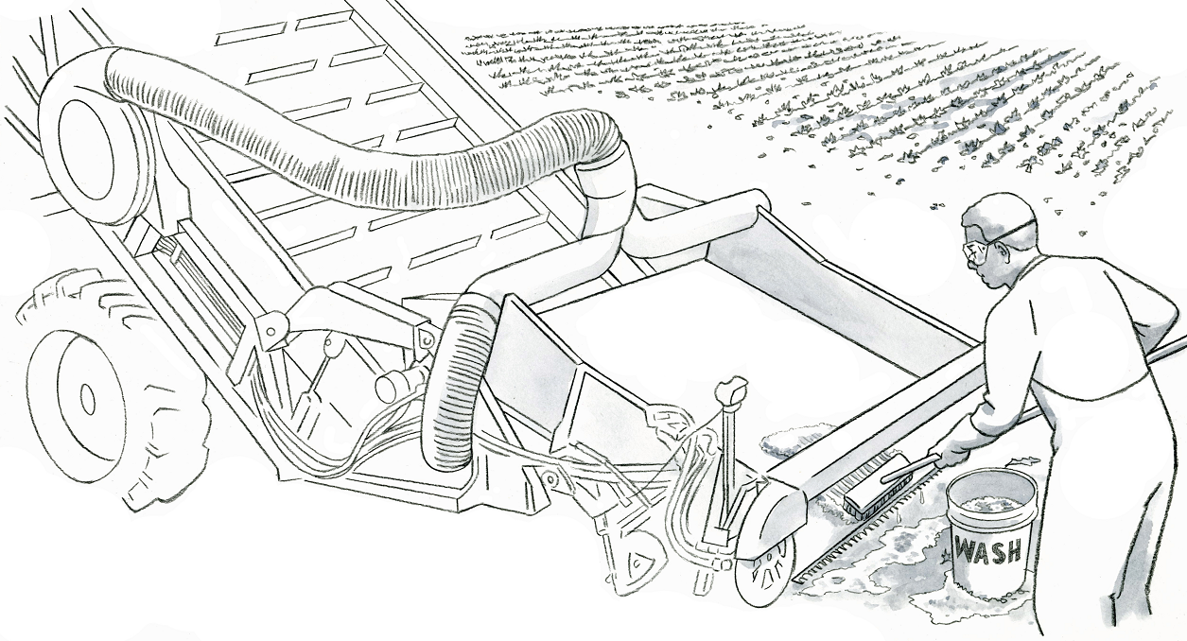
1
4
3
2

Key Teaching Points
In this illustration, a worker cleans a leafy greens harvester using a long-handled scrub brush and foaming detergent. The numbers below align with key teaching points in the above illustration.
- The long handle of the scrub brush allows the worker to reach and clean all areas of the harvester. The foaming detergent ensures that the cleaner comes into contact with crevices in the harvester, including corners and conveyor belt. The FSMA Produce Safety Rule (PSR) requires that all food contact surfaces, including harvest tools, be inspected, maintained, cleaned, and when necessary and appropriate, sanitized (§ 112.123(d)(1)).
- After cleaning, the worker or a supervisor will visually assess the harvesting equipment “for remaining residues, such as visible soil, food residue, grease, or other material” (FSMA Produce Safety Rule Draft Guidance, page 98). In this case, additional soil and leaf matter.
- The worker is wearing Personal Protective Equipment (PPE), including protective glasses, gloves, and an apron, to protect him from the foaming detergent.
- Grey water, such as the water used to wash the harvester, must be properly disposed of so that it does not contaminate food contact surfaces and other areas used for covered activities (FSMA PSR § 112.132). In this scene, the risk of contamination is low because this lettuce field has already been harvested. If the lettuce field were not yet harvested, the worker would need to ensure that the grey water does not come into contact with covered produce or areas used for covered activities.
Relevant FSMA PSR Provisions
- § 112.123(d)(1)
- § 112.132
Suggested for Use in PSA Grower Training Version 1.2
- Module 6: Postharvest Handling and Sanitation after Slide 21

Supporting Resources
- Produce Safety Alliance—Cleaning and Sanitizing.
- FSMA PSR—Draft Guidance.
- Produce Safety Alliance—Records Required by the FSMA PSR.

