Harvest Bin Inspection
Illustration Guide and Teaching Notes
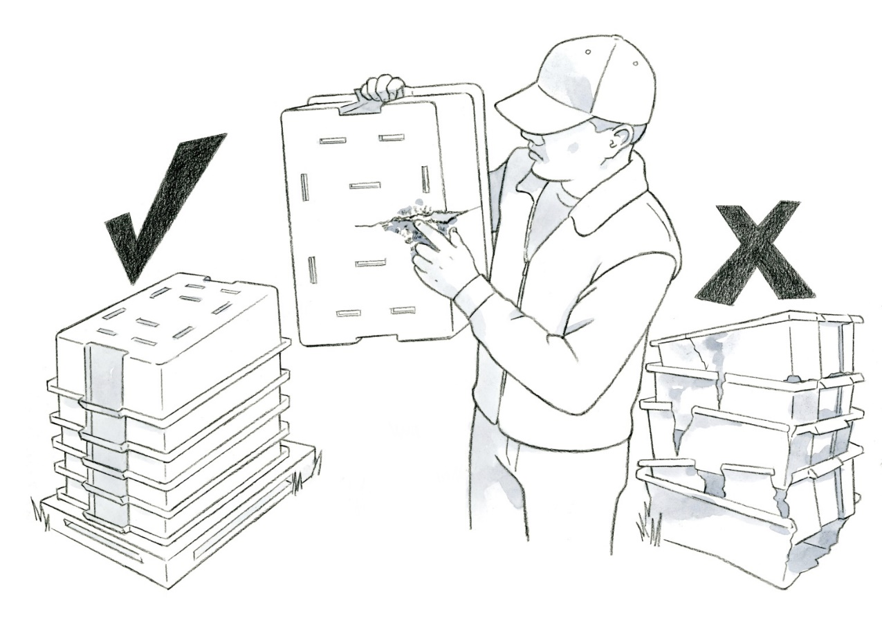

1

2b
2a

Key Teaching Points
Food contact surfaces, including harvest totes and containers, must be in good condition so they do not serve as a source of contamination from pathogen niches (such as in cracks, deep grooves, or damaged areas) and can be easily cleaned, and when appropriate, sanitized. The numbers below align with key teaching points in the above illustration.
- In this illustration, a worker is inspecting reusable plastic containers (RPCs) prior to harvest. Review FSMA Produce Safety Rule (PSR) § 112.22(b)(3) regarding worker responsibilities for harvest containers and equipment and § 112.123 on the condition of equipment and tools.
- Farms and packinghouses may have varying protocols for inspecting, cleaning, and when appropriate, sanitizing their harvest containers (FSMA PSR § 112.111(b)). A standard operating procedure (SOP) can be valuable to direct workers on these steps, including (a) what to do with containers that require repairs or replacement and (b) how and where clean harvest containers need to be stored. The clean harvest containers in this illustration are neatly stacked upside down on a pallet, so that containers are not touching the ground and dirt and debris will not fall into the clean surface inside. Organizing the clean containers in a standardized manner indicates to workers that they are ready for use (FSMA PSR § 112.123).

Relevant FSMA PSR Provisions
- § 112.22(b)(3)
- § 112.111(b)
- § 112.123

Suggested for Use in PSA Grower Training Version 1.2
- Module 2: Worker Health, Hygiene, and Training after Slide 15
- Module 6: Postharvest Handling and Sanitation after Slide 26 or 27

