**Food Safety in Packinghouse Coolers  
Illustration Guide and Teaching Notes**

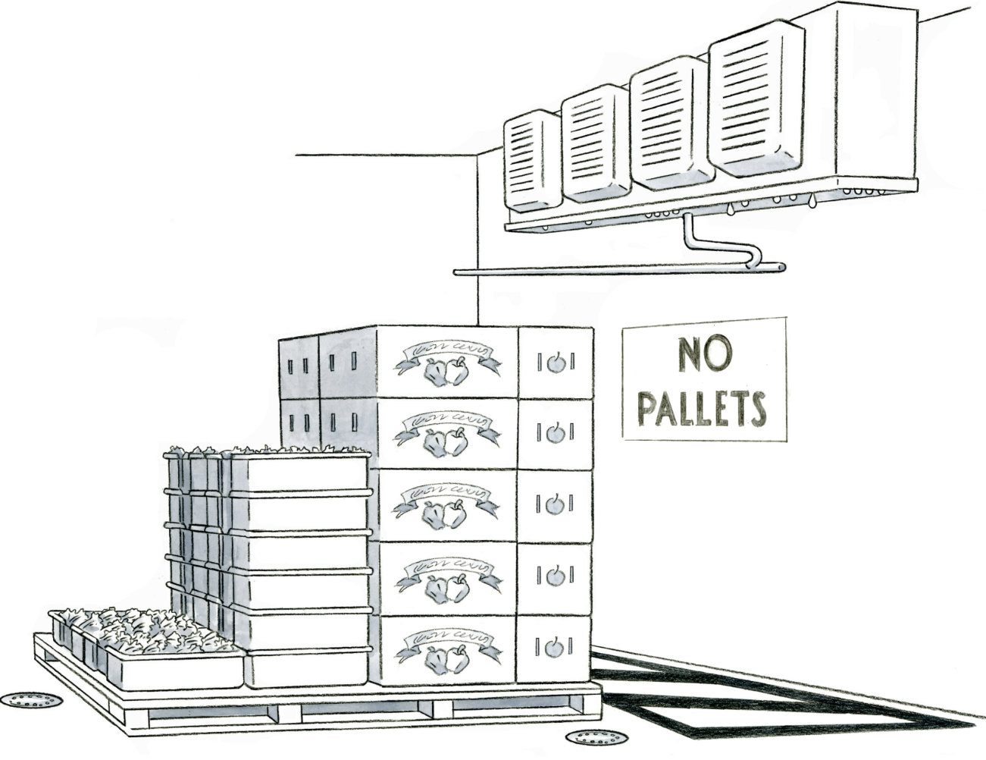

**1**

**3**

**2**

**Key Teaching Points**

In this illustration, a pallet of assorted produce crops (leafy greens, peppers, and apples) is stored in a cooler. The numbers below align with key teaching points in the above illustration.

1. The pallet holds the boxes and trays off the ground, away from any moisture accumulating on the floor. The floor drains will also help minimize water pooling on the ground. FSMA Produce Safety Rule (PSR) § 112.123 establishes requirements for equipment and tools, including coolers. Recommendations for cold storage areas are provided in Module 6 Slide 30.
2. Small droplets of water are shown on the bottom of the condenser unit in the cooler. This condensate could carry pathogens, such as *Listeria monocytogenes*. The FSMA PSR   
   § 112.126(b) requires measures be taken to prevent contamination of produce and food contact surfaces from drip or condensate.
3. Black diagonal lines painted on the floor and a “No Pallets” sign on the wall indicate that the produce should not be stored under the condenser unit. These measures will minimize contamination.

Additional discussion topics related to food safety in packinghouse coolers:

* Thermostats, thermometers, and other cooler controls are not shown in the illustration, however FSMA PSR § 112.124 requires that instruments used to measure, record, and regulate temperature be kept accurate and precise, be maintained, and be adequate in number.

**Relevant FSMA PSR Provisions**

* § 112.123
* § 112.124
* § 112.126(b)

**Suggested for Use in PSA Grower Training Version 1.2**

* Module 6: Postharvest Handling and Sanitation after Slide 30