**Flooding and Implications for Harvest**

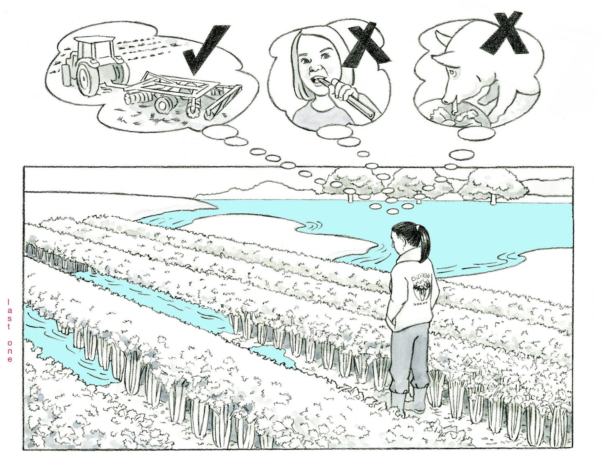**Illustration Guide and Teaching Notes**

3

2

1

**Key Teaching Points**

This illustration is intended to define flooding and identify its implications on harvesting produce. Flooding is the overflowing of a field with surface waters such as rivers, lakes, or streams. Flood waters are likely to contain physical, chemical, and biological contaminants, such as garbage, sewage, chemicals, heavy metals, and pathogenic microorganisms that may be harmful to the health of humans and animals. Flooding is different than in-field pooling; there is an accompanying illustration entitled “In-Field Pooling and Implications for Harvest” which provides more details. The numbers below align with key teaching points in the above illustration.

1. In this illustration, a river has overflowed and comes into direct contact with the celery field. The grower is evaluating the safety of this crop. Any harvestable portion of the crop that has been contacted by the flood waters is considered adulterated and cannot be harvested (Federal Food, Drug, and Cosmetic Act, § 342). There is no practical method to recondition the produce so that it is safe for consumption.   
   Thinking beyond this illustration, food crops most likely to be impacted by flooding are surface crops such as leafy greens, tomatoes, green beans, berries, and corn; underground crops, such as peanuts, potatoes, carrots, and garlic; and even food crops with a hard, outer skin or shell, such as watermelons and winter squash. According to the FSMA Produce Safety Rule (PSR) § 112.11, the grower must take measures to minimize health consequences or death from covered produce including providing “reasonable assurances that the produce is not adulterated under section 402 of the Federal Food, Drug, and Cosmetic Act[…]”.
2. The two “X” thought bubbles indicate that the celery crop must not be harvested for human or animal consumption. FDA does provide a path for using flooded crops for animal feed but only if a thorough evaluation and explicit standards are achieved. Guidance documents in the Supporting Resources include more detail about evaluating flood-effected produce crops. The “C:\Users\ljg233\AppData\Local\Microsoft\Windows\INetCache\Content.MSO\8A95EB05.tmp” thought bubble indicates that the celery crops should be disposed in a way that does not adulterate adjacent crops. Tilling the crop under is one method of destruction. For further insight, refer to the “FDA Guidance for Industry: Evaluating the Safety of Flood-affected Food Crops for Human Consumption”.
3. Crops near flooded areas or those where the harvestable part of the plant did not come in contact with the flood water need to be evaluated on a case-by-case basis. These crops, as well as those in which the harvestable portion develops after flood waters recede, are not automatically deemed adulterated. The FDA Guidance for Industry describes additional considerations for assessing flood water and replanting flood-affected fields.

**Relevant FSMA PSR Provisions**

* § 112.11

**Relevant Federal Food, Drug, and Cosmetic Act (FD&C) Provisions**

* 21 U.S. Code, [FD&C Chapter 9, § 321(f)](https://www.law.cornell.edu/uscode/text/21/321) (establishes the definition of food)
* 21 U.S. Code, [FD&C Chapter 9, § 331](https://www.law.cornell.edu/uscode/text/21/331) (establishes prohibited acts, including the adulteration of any food in interstate commerce). Note: 21 USC § 331 is the same as Section 402 in the Code of Federal Regulations.
* 21 U.S. Code, [FD&C (Chapter 9), § 342](https://www.law.cornell.edu/uscode/text/21/342) (establishes the definition of adulteration)

**Suggested for Use in PSA Grower Training Version 1.2**

* Module 5-1 Agricultural Water Part 1: Production Water after Slide 38

**Supporting Resources**

* FDA [Guidance for Industry: Evaluating the Safety of Flood-affected Food Crops for Human Consumption](https://www.fda.gov/regulatory-information/search-fda-guidance-documents/guidance-industry-evaluating-safety-flood-affected-food-crops-human-consumption).
* FDA [Safety of Food and Animal Food Crops Affected by Hurricanes, Flooding, and Power Outages](https://www.fda.gov/food/food-safety-during-emergencies/safety-food-and-animal-food-crops-affected-hurricanes-flooding-and-power-outages).
* FDA [Resources for Human and Animal Food Producers Affected by Flooding](https://www.fda.gov/about-fda/office-human-and-animal-food-operations/resources-human-and-animal-food-producers-affected-flooding).
* Produce Safety Alliance—[Food Safety for Flooded Farms](https://resources.producesafetyalliance.cornell.edu/documents/Food-Safety-for-Flooded-Farms.pdf).
* Kansas State University/University of Missouri Extension—[Frequently Asked Questions About Handling Flooded Produce.](https://ipm.missouri.edu/MEG/2017/5/FAQfloodedProduce/)