FSMA PSR Visitor Requirements
Illustration Guide and Teaching Notes

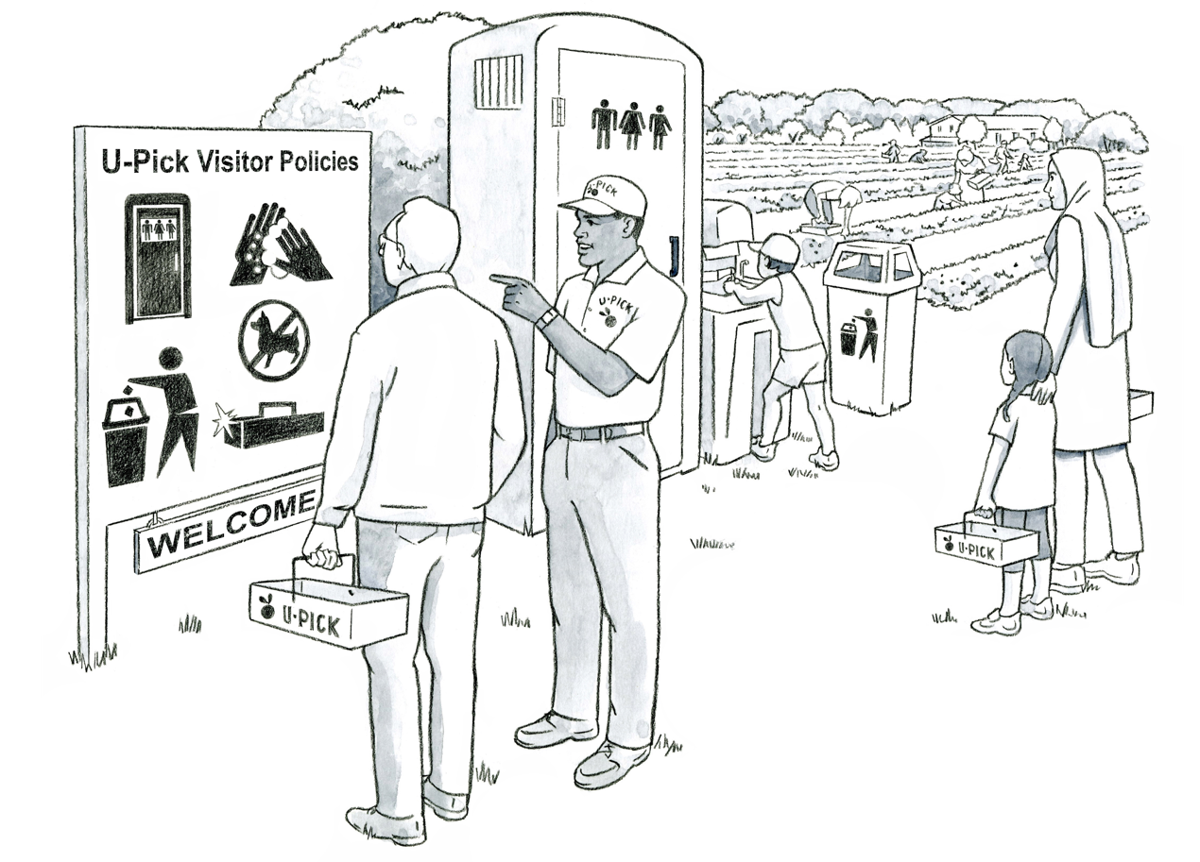
2
11

Key Teaching Points
This illustration depicts FSMA Produce Safety Rule (PSR) visitor requirements. The definition of a “visitor” in the PSR is any person (other than farm personnel) who enters a covered farm with permission. Review Preamble comments 114, 157, 172, and 173 for further insights related to visitors. The numbers below align with key teaching points in the above illustration.
- Visitors must be made aware of the farm’s policies and procedures to protect covered produce and food contact surfaces from contamination with microorganisms of public health significance (FSMA PSR § 112.33(a)). The farm owner is discussing the U-pick policies on his farm that each visitor must be aware of before entering the field. The images on the sign cover several topics that may be part of a farm’s food safety policies, such as requiring visitors to wash their hands before picking, using clean picking containers, leaving their pets at home, properly using provided toilet facilities, and depositing trash in provided cans.
In addition, a farm’s food safety policies may also include instructing visitors to not enter the field if they are sick or have symptoms of an illness (FSMA PSR § 112.31). The FSMA PSR does not specify how policies should be shared with visitors, so farm personnel could share this information using posters, handouts, or verbally as visitors enter the farm.
- Farms must also provide visitors with access to toilet and handwashing facilities (FSMA PSR § 112.33(b)). The toilet and handwashing station in this illustration is convenient for customers to use and is located outside of the produce growing area, so that potential contamination of the fields from the restrooms is minimized.
Relevant FSMA PSR Provisions
- § 112.31
- § 112.33(a)
- § 112.33(b)
Suggested for Use in PSA Grower Training Version 1.2
- Module 2: Worker Health, Hygiene, and Training after Slides 11 or 23

Supporting Resources
- National Young Farmers Coalition—Volunteers, Visitors, and Food Safety.
- FSMA PSR Preamble comments 114, 157, 172 and 173

