**Exemptions and Exclusions – Non-Produce Food Grains**

**Illustration Guide and Teaching Notes**

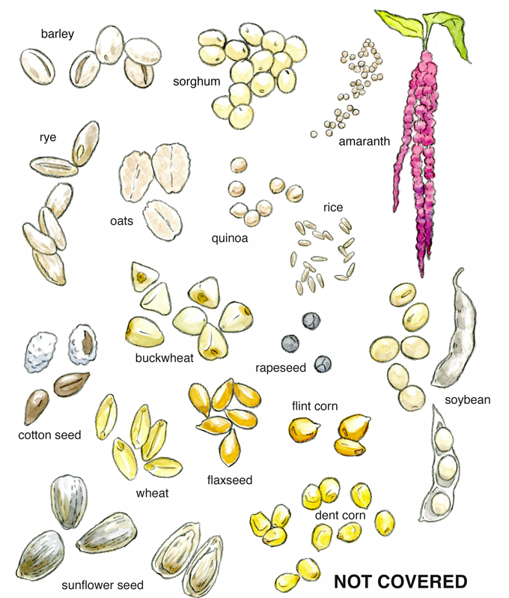

**2**

**1**

**Key Teaching Point**

This illustration includes crops that do not meet the definition of produce in the FSMA Produce Safety Rule (PSR) so they are not covered by the PSR. The numbers below align with key teaching points in the above illustration.

* 1. In § 112.3, the FSMA PSR defines produce as “any fruit or vegetable (including mixes of intact fruits and vegetables), and includes mushrooms, sprouts (irrespective of seed source), peanuts, tree nuts, and herbs.” Additionally, the definition in FSMA PSR § 112.3 states “Produce does not include food grains meaning the small, hard fruits or seeds of arable crops, or the crops bearing these fruits or seeds, that are primarily grown and processed for use as meal, flour, baked goods, cereals and oils rather than for direct consumption as small, hard fruits or seeds (including cereal grains, pseudo cereals, oilseeds and other plants used in the same fashion)”.
  2. “Examples of food grains include barley, dent- or flint-corn, sorghum, oats, rice, rye, wheat, amaranth, quinoa, buckwheat, and oilseeds (e.g., cotton seed, flaxseed, rapeseed, soybean, and sunflower seed)”. This list of grains is not exhaustive. For further insight, please refer to FSMA PSR § 112.3 under the definition of “Produce”, and Preamble comment 58.
* There is also a version of this illustration without name labels that can be used to let participants guess which crops are not considered produce items.

**Relevant FSMA PSR Provisions**

* § 112.3

**Suggested for Use in PSA Grower Training Version 1.2**

* Module 1: Introduction to Produce Safety after Slide 7

**Supporting Resources:**

* FSMA PSR [Preamble Comment 58](https://www.govinfo.gov/content/pkg/FR-2015-11-27/pdf/2015-28159.pdf).