Exemptions and Exclusions – Determining a Farm’s Status
Illustration Guide and Teaching Notes
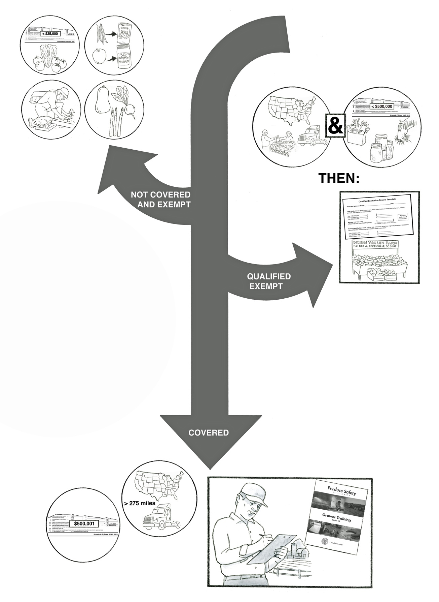
1b
1a
2a

1d
1c

2b

3a

3b

Key Teaching Points
This illustration is intended to help clarify exemptions and exclusions within the FSMA Produce Safety Rule (PSR), including crops that are covered, crops that are Rarely Consumed Raw (RCR), farms that are qualified exempt, and farms covered by the FSMA PSR. Terms and vocabulary are very important in this illustration, so referring directly to the FSMA PSR will help. The FDA Factsheet Standards for Produce Safety Coverage and Exemptions/Exclusions for 21 PART 112 (https://www.fda.gov/media/95351/download) is also a good reference to pair with this illustration. The numbers below align with key teaching points in the above illustration.
1a. Farms with an average annual value of produce sold during the previous three-year period of $25,000 or less (adjusted for inflation) would not be covered by the FSMA PSR. The 2011 Schedule F form included in the illustration demonstrates that the <$25,000 value is adjusted for inflation, based on 2011 values. Note that this value includes all produce sales not just ‘covered produce’ (FSMA PSR § 112.4).
1b. FSMA PSR § 112.2(b)(1) states that produce is eligible for an exemption if the produce receives commercial processing that adequately reduces the presence of microorganisms of public health significance. This image highlights produce that has undergone a heat treatment, or “kill-step” that incorporates a validated process to eliminate spore-forming microorganisms. There is another illustration with teaching notes in this collection entitled Exemptions and Exclusions – Commercial Processing which depicts this provision in more detail.
1c. FSMA PSR § 112.2(a)(2) states that produce used for personal or on-farm consumption is not covered. In the illustration, the man gardening in front of his house demonstrates this concept.
1d. FSMA PSR § 112.2(a)(1) establishes a list of rarely consumed raw commodities that are not covered by the regulation. The winter squash, garden beet, and asparagus depicted in this illustration are three commodities on the rarely consumed raw list. This exhaustive list contains 34 produce items in total. There is another illustration with teaching notes in this collection entitled Exemptions and Exclusions – Rarely Consumed Raw which depicts this provision in more detail.
2a. FSMA PSR § 112.5 allows farms to be eligible for a qualified exemption from most requirements of the regulation. To be eligible for a qualified exemption, the farm must meet both requirements:
- The farm’s direct food sales to qualified end-users must exceed sales to all buyers combined during the previous three years (FSMA PSR § 112.5(a)(1)). A qualified end-user is either the consumer of the food or a restaurant or retail food establishment that is located in the same state or the same Indian reservation as the farm. Restaurants, retail establishments, and consumers located in another state or country may be qualified end users if they are within 275 miles of the farm (depicted by the truck and United States map).
- The farm must have food sales averaging less than $500,000 per year adjusted for inflation during the previous three years (FSMA PSR § 112.5(a)(2)). The 2011 Schedule F form included in the illustration demonstrates that the <$500,000 value is adjusted for inflation, based on 2011 values. Note that this value includes all food sales (not just produce items), as indicated in this illustration by the horse consuming animal feed, jarred goods, and groceries.
2b. Qualified exempt farms must meet certain modified requirements, as indicated within the box in this illustration. FSMA PSR § 112.6(b) states that qualified exempt farms must display the name and complete business address of the farm where the produce was grown (depicted in this illustration as a sign at the produce stand) and must establish and keep certain documentation (depicted in this illustration as the Qualified Exemption Review record template).
3a. Farms who do not meet one of the exemptions and exclusions listed above will be covered by the FSMA PSR. This may include farms selling over $500,000 in total food sales, adjusted for inflation (depicted in this illustration as a 2011 Schedule F tax form with a value of $500,001). This may also include farms selling a majority of foods to non-qualified end users (depicted in this illustration as a truck and United States map exceeding 275 miles). For more details on the exemptions and exclusions, please review FSMA PSR §§ 112.2, 112.4, 112.5, and 112.6, or the teaching notes above.
3b. Farms covered under the FSMA PSR must meet all applicable requirements established in the regulation. These covered farms may be subject to a regulatory inspection. In this illustration, the FSMA PSR requirements, including attendance at a PSA Grower Training Course and specific records, are depicted within a box to indicate that these are required practices.

Relevant FSMA PSR Provisions
- § 112.2(a)
- § 112.2(b)(1)
- § 112.4
- § 112.5
- § 112.6

Suggested for Use in PSA Grower Training Version 1.2
- Module 1: Introduction to Produce Safety after Slide 7

Supporting Resources
- FDA. FSMA PSR Coverage and Exemptions/Exclusions Flow Chart.
- FDA. FSMA Inflation Adjusted Cut Offs.
- Produce Safety Alliance - Records Required by the FSMA PSR.
- Produce Safety Alliance - FSMA PSR Exemptions & Exclusions (PowerPoint).

