Exemptions and Exclusions – Commercial Processing
Illustration Guide and Teaching Notes
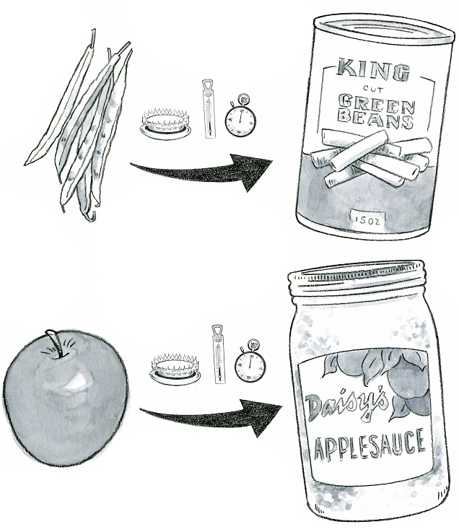
2

1

Key Teaching Points
This illustration shows produce that has undergone a heat treatment, or “kill-step”. The numbers below align with key teaching points in the above illustration.
- The FSMA Produce Safety Rule (PSR) § 112.2(b)(1) states that produce is eligible for exemption if the produce receives commercial processing that adequately reduces the presence of microorganisms of public health significance.
- If a grower is selling the raw agricultural product to a processor, FSMA PSR
§ 112.2(b)(2) states the grower must disclose to the buyer that the food is “not processed to adequately reduce the presence of microorganisms of public health significance”. The grower must also either obtain written assurances from the customer that performs the commercial processing or a written assurance from the customer that an entity in the distribution chain will perform the commercial processing. For growers interested in understanding requirements for exemptions, reviewing all the sections of FSMA PSR provision § 112.2(b) is recommended as well as Preamble comments 58-61.

Relevant FSMA PSR Provisions
- § 112.2(b)(1)
- § 112.2(b)(2)

Suggested for Use in PSA Grower Training Version 1.2
- Module 1: Introduction to Produce Safety after Slide 7

Supporting Resources:
- FSMA PSR Preamble Comments 58-61.

