Establishing No Harvest Buffer Zones
Illustration Guide and Teaching Notes
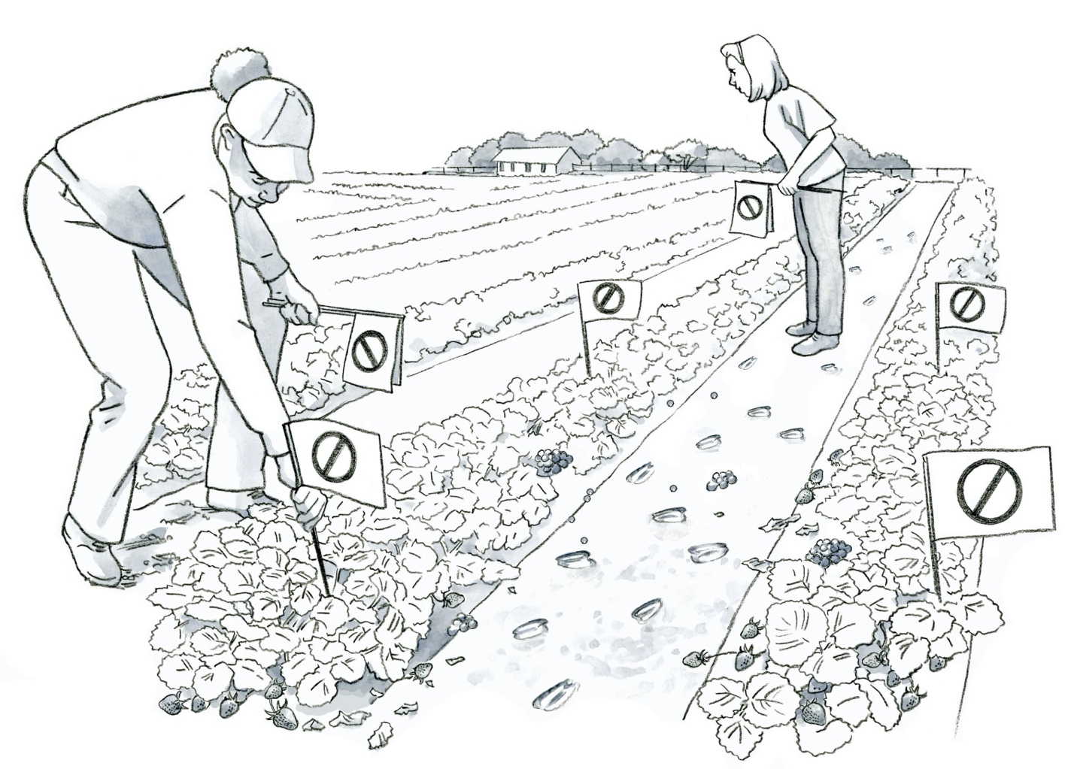
3
2
1
Key Teaching Points
Workers must be able to recognize when produce must not be harvested. This requires training and understanding food safety risks in the field, such as those from wildlife or domestic animals. Review FSMA Produce Safety Rule (PSR) §§ 112.22(b)(1), 112.83, and 112.112. The numbers below align with key teaching points in the above illustration.
- In this illustration, two workers scout for evidence of animal intrusion and fecal contamination in a strawberry field prior to harvest. Visible hoof prints and deer feces are shown in the rows as well as in the path between the rows of strawberries.
- While buffer zones are not required to be established by the FSMA PSR, they are one way to manage risk. Buffer zones may vary from a 1-25 foot radius, depending on the type of feces, extent of the contamination, and environmental conditions such as prior rain or wind events. Growers should also consult with current industry guidance and marketing agreements for specifics of buffer zone distances required for certain commodities such as leafy greens.

- Workers who harvest produce must receive training on how to recognize covered produce that must not be harvested, including produce that may be contaminated (FSMA PSR § 112.22(b)(1)). In this illustration, flags are being placed to denote areas which must not be harvested due to fecal contamination and animal intrusion.

Additional discussion topic related to no-harvest buffer zones:
- Does the standard operating procedure (SOP) require them to flag and remove the contamination in addition to not harvesting the affected produce? If so, worker hygiene will be critical after handling fecal material to ensure it does not cross-contaminate produce from hands, tools, or equipment (FSMA PSR § 112.32(b)).
Relevant FSMA PSR Provisions
- § 112.22(b)(1)
- § 112.32(b)
- § 112.83
- § 112.112

Suggested for Use in PSA Grower Training Version 1.2
- Module 2: Worker Health, Hygiene, and Training after Slide 15
- Module 4: Wildlife, Domesticated Animals, and Land Use after Slide 22

Supporting Resources
- California Leafy Green Products Handler Marketing Agreement (LGMA) —Assessing Animal Activity in the Field.
- Farm Food Safety Decision Trees—Wildlife and Animal Activity Decision Tree.

