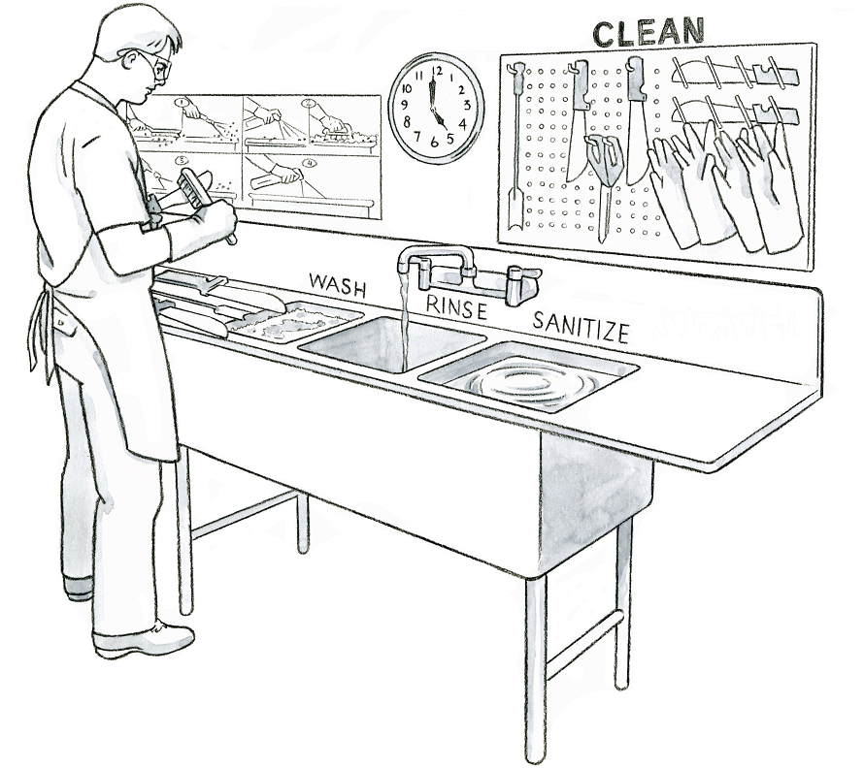**Cleaning and Sanitizing Tools  
Illustration Guide and Teaching Notes**

**5**

**4**

**3**

**2**

**1**

**Key Teaching Points**

In this illustration, small harvest tools are being cleaned and sanitized at the end of the workday. The numbers below align with key teaching points in the above illustration.

1. A worker is scrubbing a harvest knife with a brush in front of a three-section sink labeled “Wash”, “Rinse” and “Sanitize”. The “Wash” basin has soapy water to help clean the tools. The “Rinse” basin uses running water to rinse off soap and dirt, resulting in clean tools. Lastly, the tools are immersed in a sanitizer solution in the “Sanitize” basin before hanging to dry. The FSMA Produce Safety Rule (PSR) § 112.123(d)(1) requires that all food contact surfaces, including harvest tools, be inspected, maintained, cleaned, and when necessary, sanitized.
2. A poster demonstrating the four-step cleaning and sanitizing process is hanging above the sink as a visual reference for the worker so they know how to properly complete the task. The FSMA PSR §§ 112.21 and 112.22 requires training for those that handle food contact surfaces including requirements for inspecting harvest equipment.
3. The worker is wearing Personal Protective Equipment (PPE), including protective glasses, gloves, and an apron, to protect him from the sanitizer.
4. Specialized cleaning tools are being used to scrub the harvest tools. This worker is specifically using a small brush to ensure the crevices between the knife blade and handle are cleaned. According to the FSMA Produce Safety Rule Draft Guidance, “food contact sources should be visually assessed for remaining residues, such as visible soil, food residue, grease, or other material” (page 98).
5. Dirty harvest tools, not yet cleaned, are on the left of the sinks to ensure clean tools are separated from dirty tools. Clean tools and gloves are hanging to dry on the pegboard above the sink. Note that everything has a designated place, including a labeled pegboard to hang clean tools to dry.

**Relevant FSMA PSR Provisions**

* § 112.21
* § 112.22
* § 112.123(d)(1)

**Suggested for Use in PSA Grower Training Version 1.2**

* Module 6: Postharvest Handling and Sanitation after Slide 21

**Supporting Resources**

* Produce Safety Alliance—[Cleaning vs. Sanitizing](https://resources.producesafetyalliance.cornell.edu/documents/Cleaning-vs-Sanitizing.pdf).
* FSMA PSR—[Draft Guidance](https://www.fda.gov/regulatory-information/search-fda-guidance-documents/draft-guidance-industry-standards-growing-harvesting-packing-and-holding-produce-human-consumption).
* Produce Safety Alliance—[Records Required by the FSMA PSR](https://resources.producesafetyalliance.cornell.edu/documents/Records-Required-by-the-FSMA-PSR.pdf).