Categorizing Biological Soil Amendments of Animal Origin
Illustration Guide and Teaching Notes

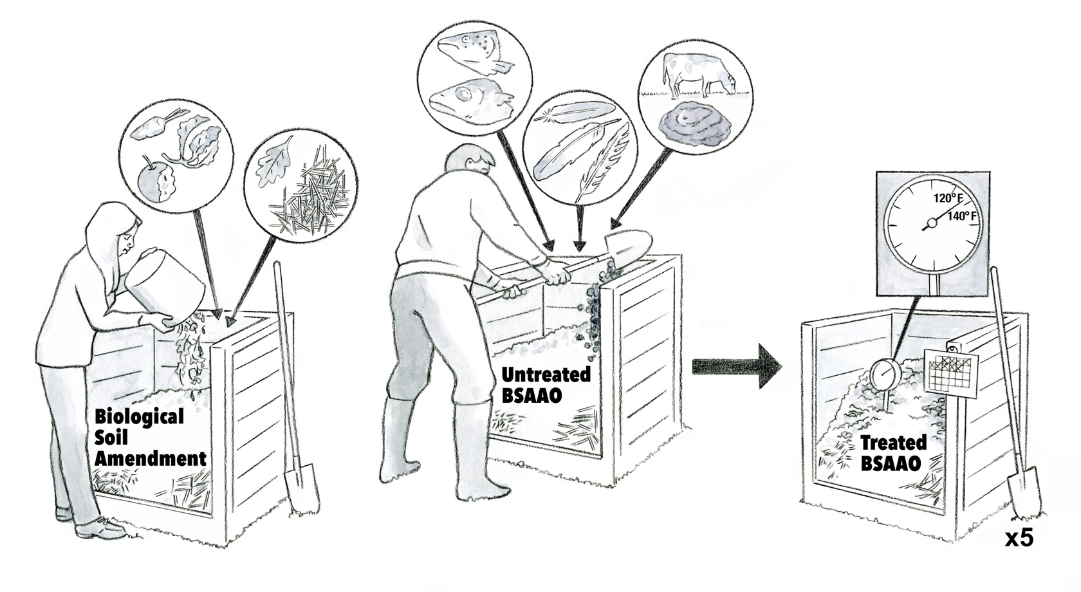
5
4
2
1
3

Key Teaching Points
This illustration is intended to distinguish the differences between key definitions in the FSMA Produce Safety Rule (PSR), including biological soil amendments, biological soil amendments of animal origin (BSAAO), and untreated vs. treated BSAAO. The FSMA PSR establishes soil amendment definitions in § 112.3(c). Being familiar with these definitions will help growers understand the risks and regulatory requirements associated with each soil amendment type. The numbers below align with key teaching points in the above illustration.
- Food preparation scraps, a type of pre-consumer vegetative waste, yard trimmings, and straw are being added to a new soil amendment pile labeled “Biological Soil Amendment". These inputs are all examples of biological soil amendments (i.e., any soil amendment containing non-animal based biological materials, alone or in combination that do not contain any form of human waste).

- Dead fish, cow manure, and feathers are being added to the developing soil amendment pile labeled “Untreated BSAAO”. Since animal products were added to this bin, it is now considered a BSAAO: a biological soil amendment which consists of materials of animal origin. This definition is important because BSAAO are regulated under the FSMA PSR. Untreated soil amendments, such as the fish, manure, and feathers added to this bin, are considered higher risk since they have not been treated to reduce pathogens. Untreated soil amendments are defined in FSMA PSR § 112.51(b) and practices for using untreated soil amendments are outlined in § 112.56.
- BSAAO can undergo a validated treatment step, such as composting, to reduce risks. This treatment step shifts the BSAAO from ‘untreated’ to ‘treated’. Due to the reduced risks of a treated BSAAO, practices for using a treated BSAAO are different than those for an untreated BSAAO (FSMA PSR § 112.56).
- The FSMA PSR establishes microbial standards in § 112.55 and outlines two treatment processes (i.e., turned composting, aerated static composting) that meet the standards in § 112.54. This illustration demonstrates the process requirements of turned composting to ensure a BSAAO is effectively treated. These steps include monitoring the temperature to ensure a minimum of 131°F for 15 days and turning the pile at least 5 times, followed by curing.
- Growers treating soil amendments, such as compost, on their farm are required to keep records of the treatment process (FSMA PSR § 112.60). The calendar record hanging on the bin would allow the grower to document the time, temperature, and turnings.

Relevant FSMA PSR Provisions

- § 112.3(c)
- § 112.51(b)
- § 112.54
- § 112.55
- § 112.56
- § 112.60

Suggested for Use in PSA Grower Training Version 1.2
- Module 3: Soil Amendments after Slide 10 or 16

Supporting Resources
- Produce Safety Alliance—Records Required by the FSMA PSR.

