Avoiding the Harvest of Contaminated Fruit
Illustration Guide and Teaching Notes

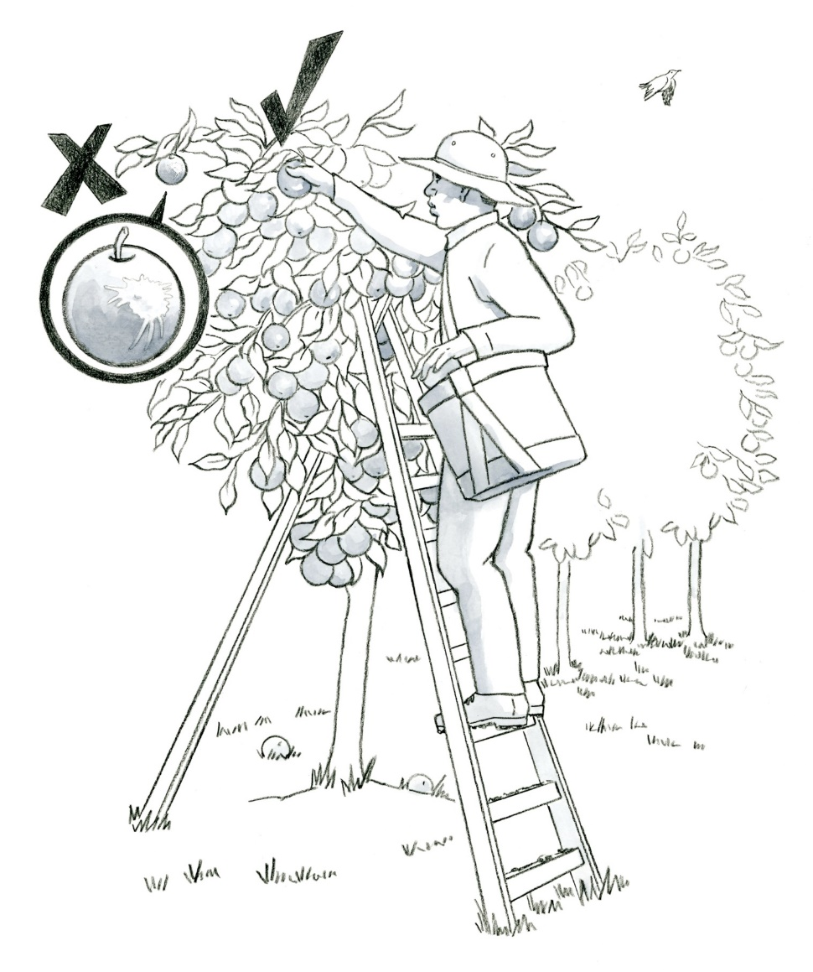
Key Teaching Points
1
3
4

2
Workers must be trained to identify and not harvest produce that may be contaminated with a known or reasonably foreseeable food safety hazard. Effective training results in workers who are empowered to make decisions and implement food safety practices everyday while they work. Review the requirements outlined in FSMA Produce Safety Rule (PSR) §§ 112.22(b)(1) and 112.112. The numbers below align with key teaching points in the above illustration.
- In this illustration, the call out bubble shows an apple with visible contamination (feces) from a bird. The “X” indicates apples with contamination must not be harvested.
The “” indicates this apple is not contaminated.
- Produce covered by the FSMA PSR which has dropped to the ground before (or during) harvest must not be distributed. Review FSMA PSR § 112.114 and preamble comments 336-339 for further insight.
- The rungs of the ladder have visible soil from the worker’s boots which could contribute to contamination of the worker’s hands if they contact the rungs as they are climbing the ladder. Hand washing and awareness of hand placement on the side rails rather than the rungs can help minimize cross-contamination risks.
- Wildlife, such as the bird in this illustration, may serve as a source of contamination to fresh produce. Review the requirements of FSMA PSR § 112.83 and discuss how to evaluate whether wildlife are resident or transient, and whether contamination is present and likely to impact the safety of the crop. What actions might a grower take if extensive bird droppings are found on a particular tree or block of an orchard?
Relevant FSMA PSR Provisions
- § 112.22(b)(1)
- § 112.83
- § 112.112
- § 112.114
Suggested for Use in PSA Grower Training Version 1.2
- Module 2: Worker Health, Hygiene, and Training after Slide 15
- Module 4: Wildlife, Domesticated Animals, and Land Use before Slide 23
- Module 6: Postharvest Handling and Sanitation after Slide 26 or 27

Supporting Resources
- California Leafy Green Products Handler Marketing Agreement (LGMA)—Assessing Animal Activity in the Field.
- National Good Agricultural Practices Program—Worker Health, Hygiene, and Training Decision Tree.
- National Good Agricultural Practices Program—Wildlife and Animal Management Decision Tree.
- FSMA PSR Preamble Comments 336-339.

